**PRACTICAL ONE**

|  |  |
| --- | --- |
| BIN2DEC |  |
|  | 100 |
|  | -1 |
| BIN2HEX |  |
|  | 00FB |
|  | E |
| BIN2OCT |  |
|  | 011 |
|  | 144 |

**ACTIVITY 4**

1. I made sure of inserting the correct fomular of the binary number conversion.
2. I made sure of copying and observing the answer it resulted.

**Conclusion**

I learnt how to convert binary number to decimal, hexadecimal and octal number.

**Excersice**

1. 7777777777
2. 10
3. 1

**PRACTICAL TWO**

|  |  |
| --- | --- |
| DEC2BIN |  |
|  | 1001 |
|  | 111001 |
| DEC2HEX |  |
|  | 0064 |
|  | FFFFFFFFCA |
| DEC2OCT |  |
|  | 072 |
|  | 7777777634 |

**ACTIVITY**

1. I made sure of inserting the correct fomular of the binary number conversion.
2. I made sure of copying and observing the answer it resulted.

COCLUSON

I learnt how to convert DECIMAL numbers to binary hexadecimal and to octal.

**PRACTICAL TWO**

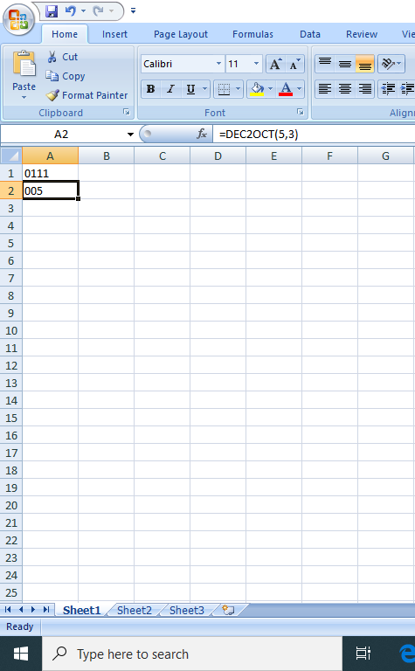

**PRACTICAL THREE**

|  |  |
| --- | --- |
| **HEX2BIN** |  |
|  | **00001111** |
|  | **10110111** |
| **HEX2DEC** |  |
|  | **183** |
|  | **-165** |
| **HEX2OCT** |  |
|  | **017** |
|  | **35516** |

**ACTIVITY**

1. I made sure of inserting the correct fomular of the binary number conversion.
2. I made sure of copying and observing the answer it resulted.

**CONCLUSION**

**I learnt how to convert hexadecimal numbers to other forms of number systems**

**Exercise**

1. **1034160313**
2. **a. OCT2BIN**

**b. OCT2DEC**

**C. OCT2HEX**

**PRACTICAL FOUR**

ACTIVITY 1

|  |
| --- |
| FALSE |
| TRUE |
| TRUE |
| TRUE |

ACTIVITY 2

|  |
| --- |
| FALSE |
| FALSE |
| FALSE |
| TRUE |

ACTIVITY 3

|  |
| --- |
| TRUE |
| FALSE |

ACTIVITY 4

|  |
| --- |
| HIGH |
| LOW |
| LOW |
| LOW |

|  |
| --- |
| HIGH |
| HIGH |
| HIGH |
| LOW |

ACTIVITY 5

1. make sure you connect and setup logical units in correct position
2. make sure you observe the correct output

conclusion

I learnt how to connect and get familiar with the different logical gates.

Exercise

1. Zero

i. C=1

ii. C=1

iii. C=0

iv. C=1

1. C=0
2. C=0
3. C=1

**PRACTICAL FIVE**

|  |  |  |
| --- | --- | --- |
| 1 | 1 | 1 |
| 0 | 1 | 0 |
| 1 | 0 | 1 |
| 1 | 0 | 1 |
| 0 | 0 | 1 |
| 0 | 1 | 0 |
| 1 | 0 | 1 |
| 0 | 0 | 0 |

**Activity 2**

1. Made sure of representing the ON OFF in the logical gates
2. Flipping the switches with care

**Conclusion**

I learnt how to implement Boolean Logic equations.

**PRACTICAL SIX**

|  |
| --- |
| **1** |
| **1** |
| **1** |
| **0** |

**ACTIVITY 2**

1. **Made sure** of implementing the Boolean logic correctly.
2. Comparism between the output of logical and logical equation correctly.

**Conclusion**

I learnt how to compare between the output and study the Boolean logical equation in accordance.

**Exercise**

= A (B+AB) + AC

AB+AAB+AC (AA=A)

AB+AB(remove one AB)

AB+AC or A(B+C)

**PRACTICAL SEVEN**

|  |  |
| --- | --- |
| **0** | **0** |
| **1** | **0** |
| **1** | **0** |
| **1** | **1** |

|  |  |
| --- | --- |
| **0** | **0** |
| **1** | **0** |
| **1** | **0** |
| **0** | **1** |
| **1** | **0** |
| **0** | **1** |
| **0** | **1** |
| **1** | **1** |

**ACTIVITY**

1. Made sure of correct input
2. Made sure of correct connection

**Conclusion**

**I** learnt how to calculate full adder and half adder.

**PRACTICAL EIGHT**

|  |  |
| --- | --- |
|  | No Change |
| **1** | **Reset** |
| **0** | **Set to 1** |
| **1** | **Prohibited** |
| **0** | **Not used** |

**Activity 2**

|  |  |  |  |  |  |
| --- | --- | --- | --- | --- | --- |
| **0** | **X** | **X** | **X** | **X** | **Hold** |
| **X** | **0** | **0** | **0** | **1** | **Prohibited** |
| **1** | **1** | **1** | **0** | **0** | **Stable** |
| **1** | **0** | **1** | **0** | **1** | **Reset** |
| **1** | **0** | **1** | **0** | **0** | **Hold** |

**Activity 3**

|  |  |  |  |  |  |
| --- | --- | --- | --- | --- | --- |
| **X** | **0** | **0** | **0** | **1** | **Changed** |
| **1** | **0** | **1** | **0** | **1** | **Reset** |
| **0** | **0** | **0** | **0** | **0** | **Hold** |
| **1** | **1** | **1** | **1** | **1** | **Not used** |
| **1** | **1** | **0** | **0** | **1** | **Not used** |
| **1** | **1** | **1** | **0** | **0** | **used** |

**Activity 6**

1. **Made sure of D-flip flop correct handling**
2. **Made sure of multism correct insertion and connecting of flip flops**

**Conclusion**

**I study the sequential circuits and counters.**

**Exercise**

